Welcome to the World of Archival Research.
Time to Get to the Evidence of History: Primary Sources!
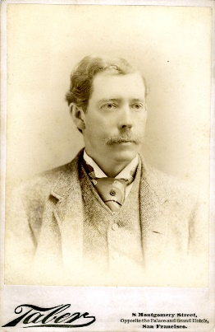
Primary sources are pieces of evidence we can use to learn about people, events and everyday life in the past. Just like detective, researchers look at clues, sift through evidence, and reach conclusions. Focus on the evidence and get a glimpse into the past beyond what a book will tell you.

Newspapers
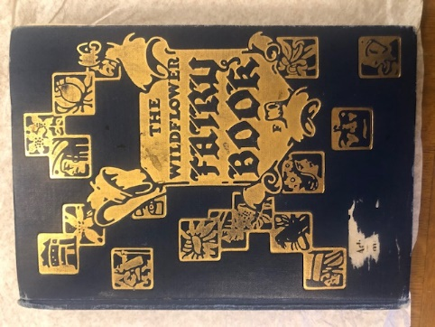
Ledgers
Census Records
Journals
Diaries
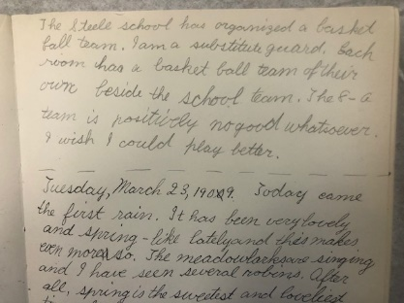
Inventories
Photographs
Correspondence
Oral Histories

This week, you have 5 Primary Source Challenges. Choose one, or choose them all! Each of you will have a chance to share your experiences completing challenges at the June 24 session. We hope you have lots of fun!
- Challenge #1: Downtown Photo Hunt
- Challenge #2: Join the Palmer Journal Challenge
- Challenge #3: Recreate a Historic Photograph
- Challenge #4: Try Out a Recipe from the CSPM Archives
- Challenge #5: Conduct an Oral History with a Friend or Family Member

Challenge #1: Downtown Photo Hunt
- Find the building or place in the photographs below.
- Photograph yourself with the building or place.
- Submit your photographs to Hillary.mannion@gmail.com
- From the photograph, determine what the building originally was.
- From your find, determine what the building is used for now.
- We will share your photos and answers on June 24.
Here is a map of Downtown showing the boundaries for the hunt. Good Luck!
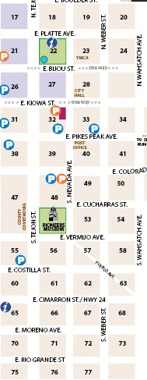
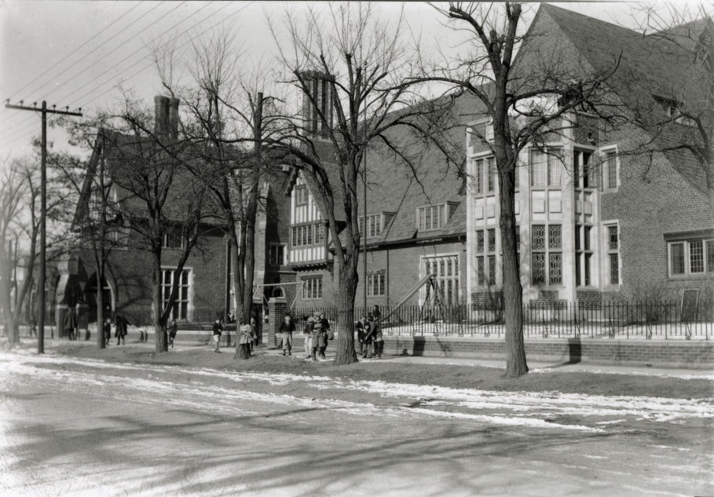
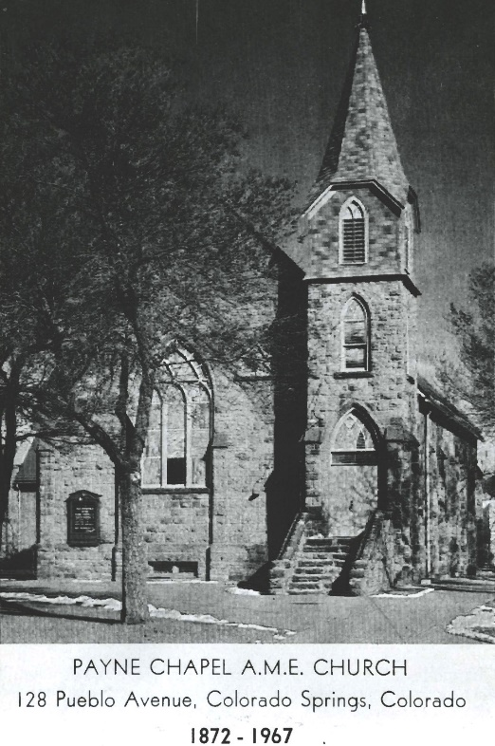

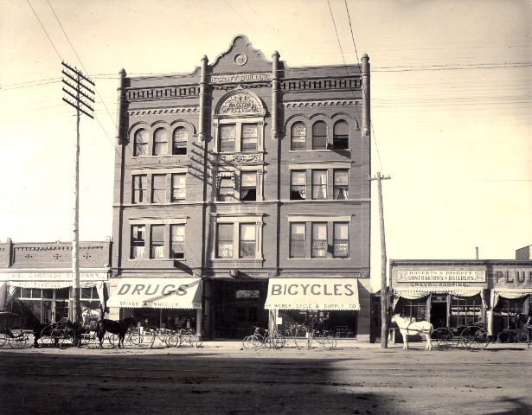 | 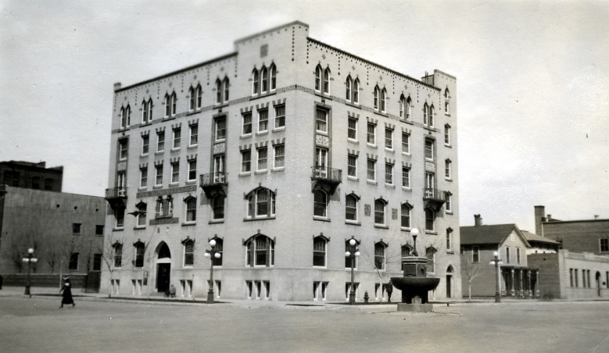
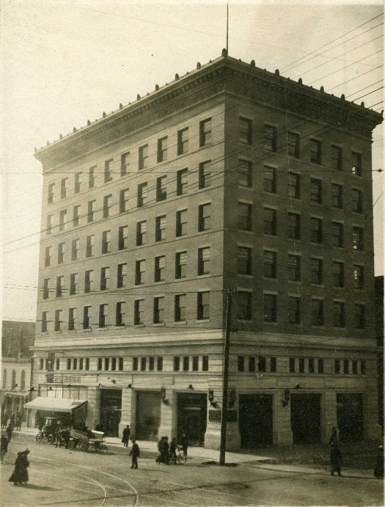 | 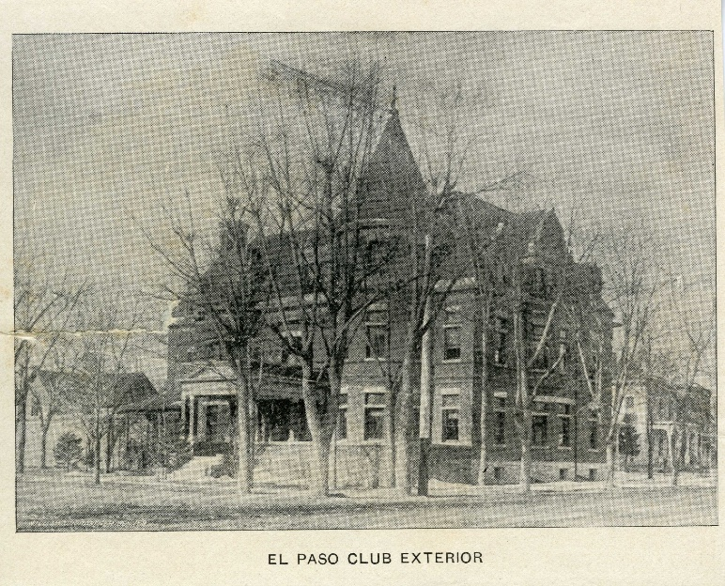
 | 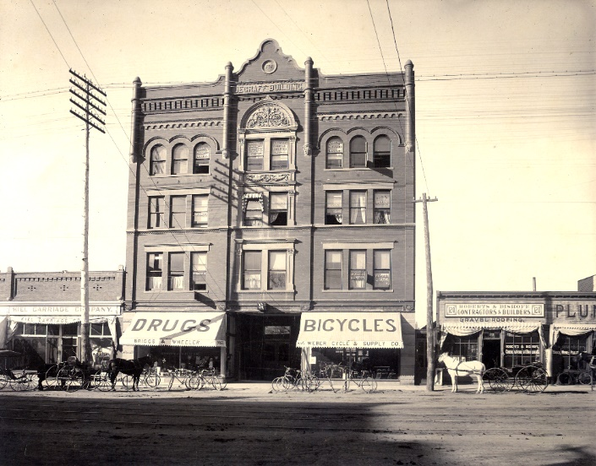
 | 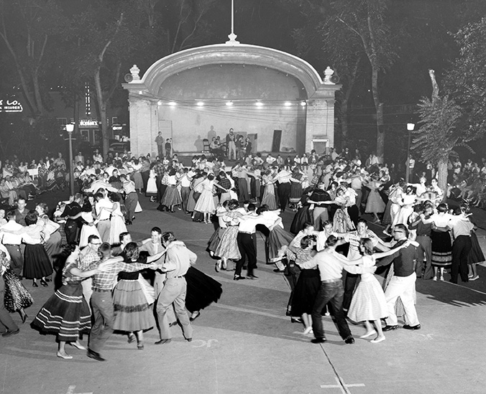

Challenge #2: Join the Palmer Journal Challenge!
Visit the Palmer Journal Challenge website and follow the instructions. Transcribe at least one page.
https://www.cspm.org/articles/palmerjournalchallenge/

Challenge #3: Recreate a Historic Photograph
Choose one or more of the photographs shown below and recreate it! Set the background scene, put together your costumes and take the photo. You may need help from family or friends.

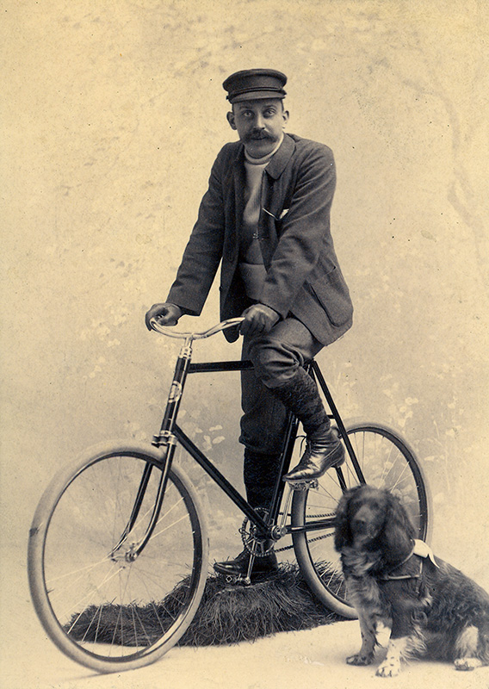

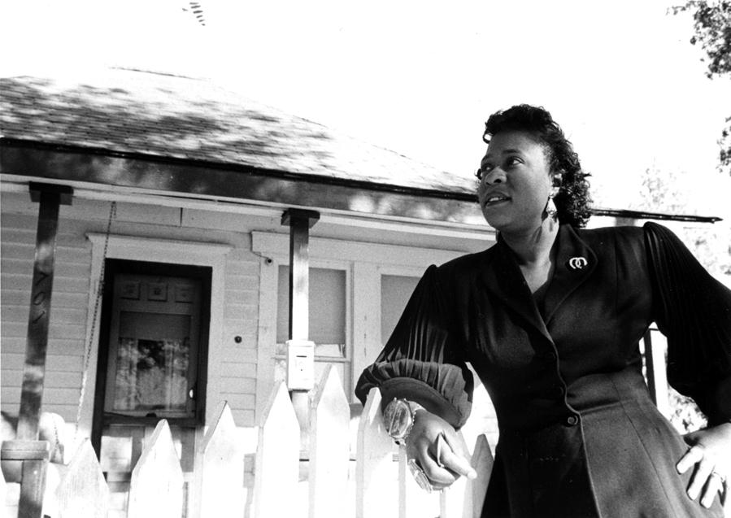

You might need to get creative for this one. . . .
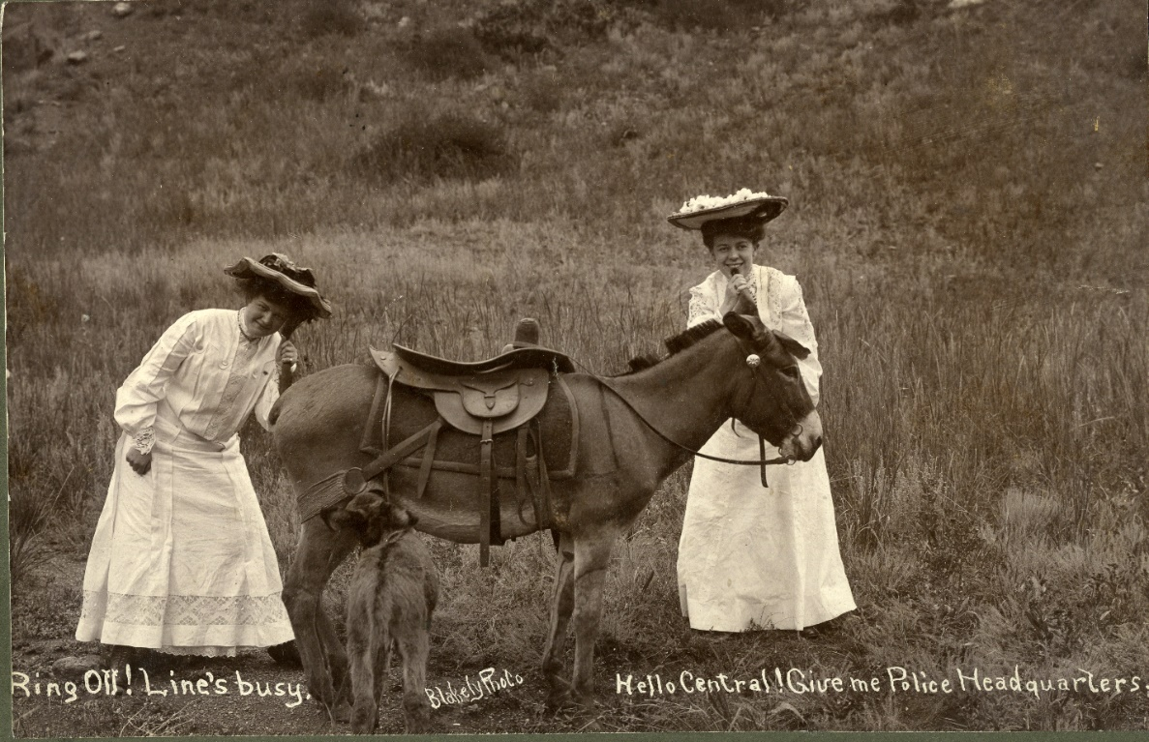

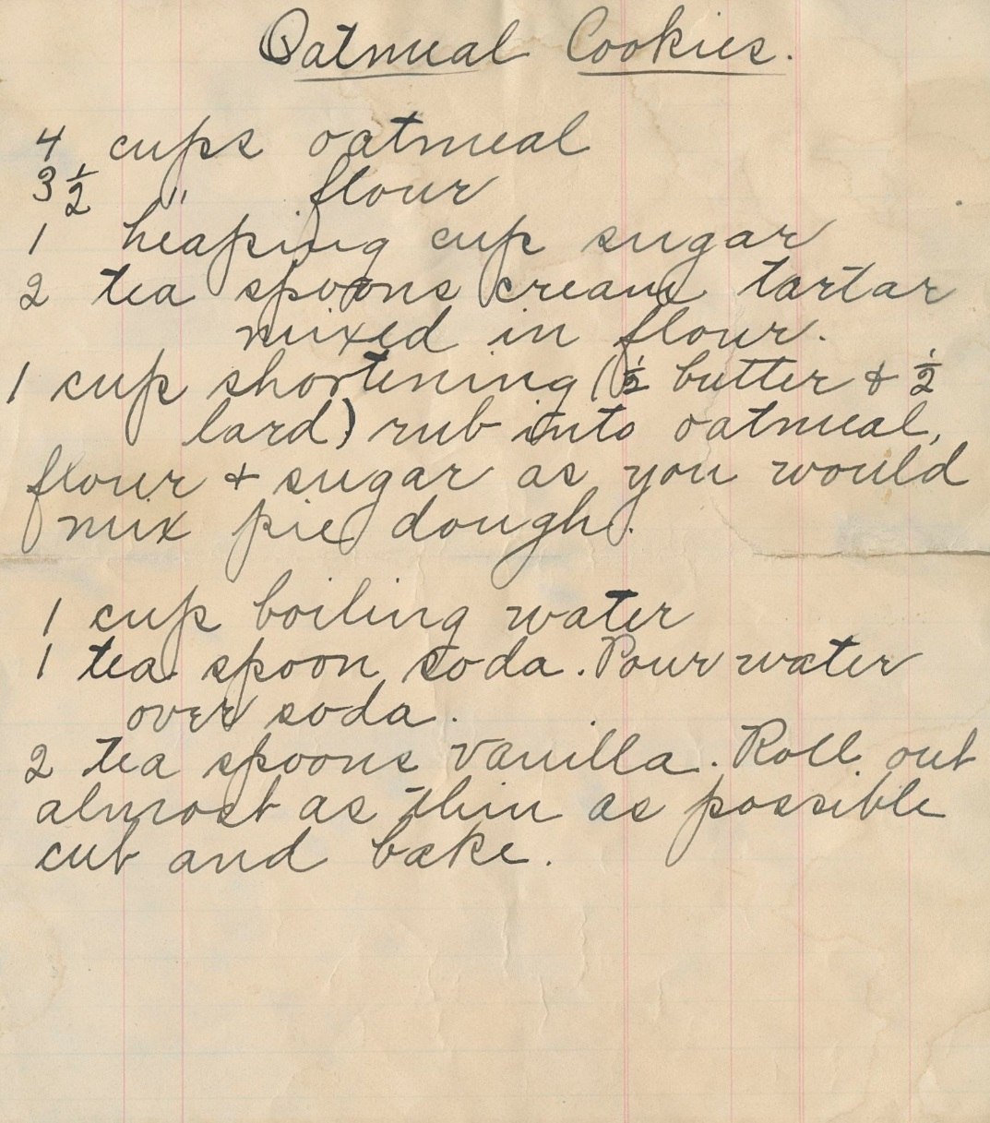
Challenge #4: Head to the kitchen and create one or all of these delectable recipes from the CSPM Archives! Take photos to share your results.

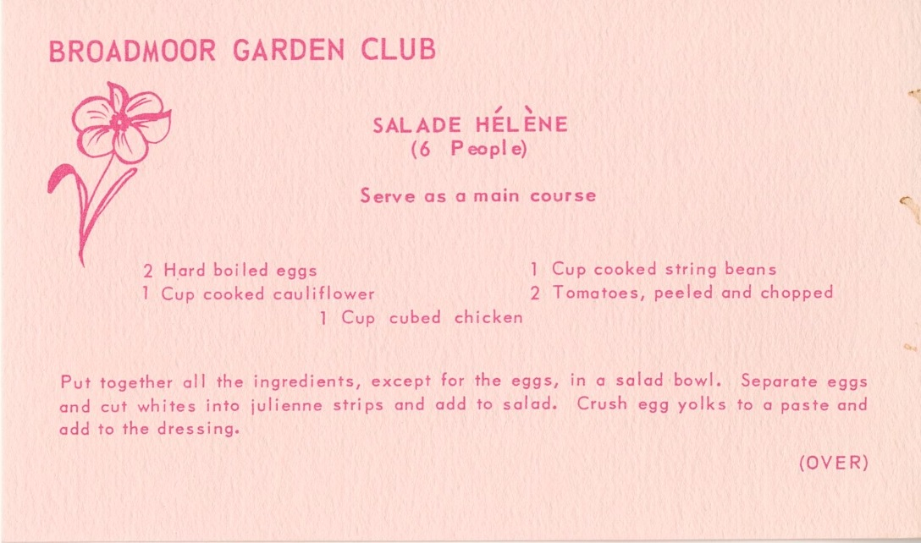
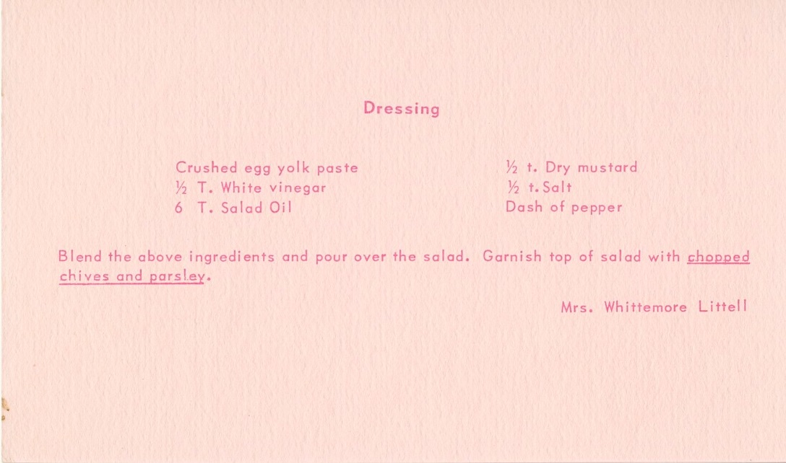

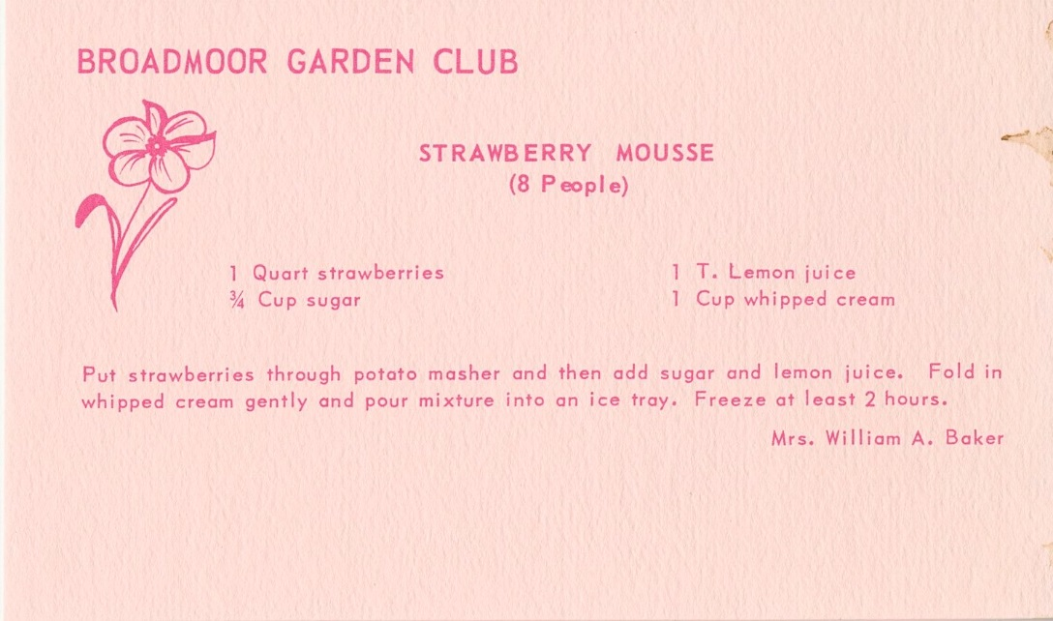
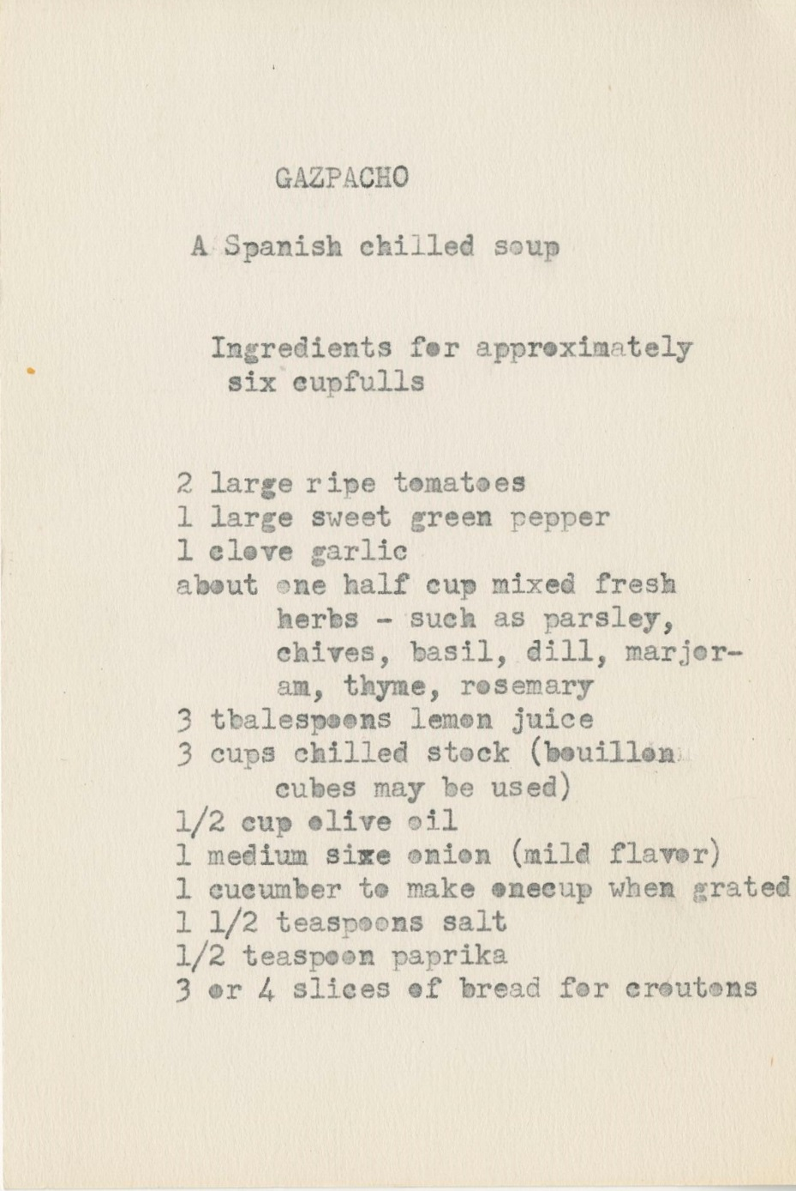

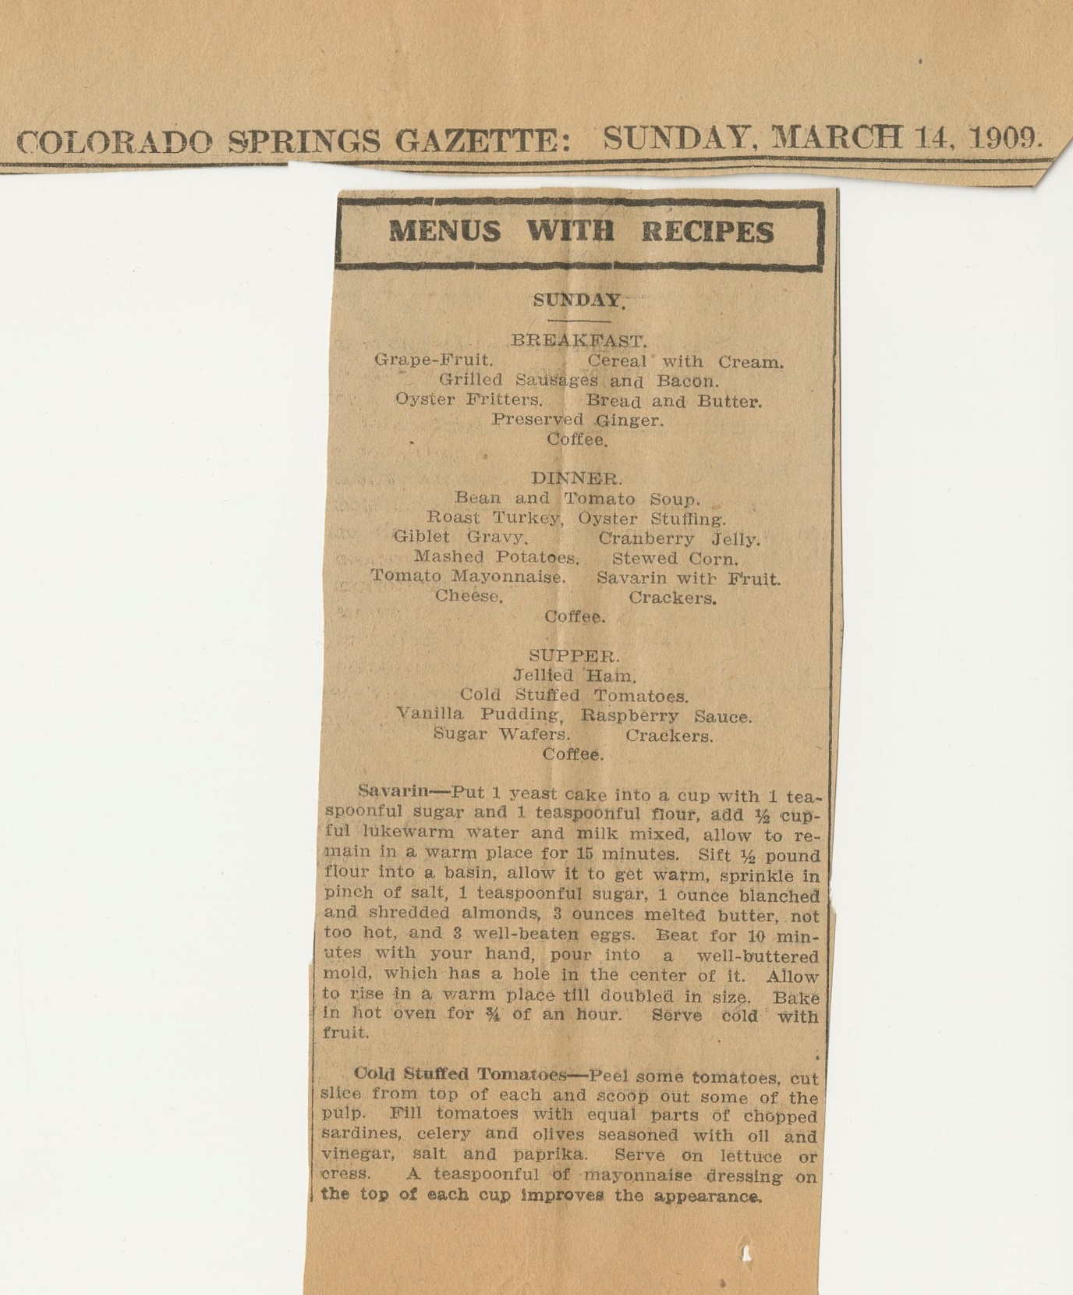

Challenge #5: Oral Histories: Interview a friend, relative or neighbor.
Oral histories are the collections of someone’s memories and interpretations of the past in their own words. They are also a record of the person’s direct feelings and opinions about the events in which he or she was involved.

Click below to access a copy of a previously recorded Oral History for some ideas!

Now It Is Your Turn!
Before the Interview:
- Determine the interview topic and write at least five basic questions relevant to the topic. Avoid simple YES and NO questions; ask open-ended questions to allow more discussion.
- Decide who you will interview to learn about this topic or time period and set up a time and place.
- Gather items that might help stimulate the informant’s memory, such as photographs, personal items, or newspaper articles.
- Make sure your recorder is working, or that you are ready to transcribe with pen and paper, or word processor.

The Interview:
- Begin the interview by stating the time, place, date, your name and the name of your informant.
- Ask the informant his or her name and place and date of birth.
- Ask your questions: Allow the informant plenty of time to answer. If he or she says something you do not understand, ask him or her to explain or clarify.

Here are some example questions:
- Describe some of your earliest memories. A few that really stand out in your mind.
- Where did you go to school? Describe the building, the teachers, your friends.
- When you were growing up, what were your plans for your future: How were these plans decided and were your goals achieved?
- What were the national/world issues which you specifically remember being involved in here in the community? Describe them.
- What events taking place in the City do you remember participating in over the years?

